Thanos

26 September 2022

19:39

Installing Prometheus Operator on master cluster.

Ensure monitoring namespace is empty

1. Create storage object to be used by Thanos.

1. Add the relevant information to thanos-storage-config.yaml and run the following.

kubectl create secret generic thanos-objstore-config --from-file=thanos.yaml=thanos-storage-config.yaml -n monitoring

This creates a secret to allow connection to your object storage.

1. Add the relevant information to value.yaml and run -

helm upgrade --install prometheus-operator stable/prometheus-operator -f values.yaml -n monitoring

You should now see the metrics appearing in your object storage.

Installing Thanos

Add relevant information thanos-store.yaml and run -

kubectl apply -f thanos-store.yaml -n monitoring

This installs a service, statefulset and configmap for storage information.

**Install thanos querier.**

kubectl apply -f querier-deployment.yaml -n monitoring

This installs a deployment. K8s has it's own embedded cluster DNS service discovery, so you can use the service name to connect to the store. These names relate to the service names - **prometheus-operated and thanos-store** in the monitoring namespace.

- --store=dnssrv+_grpc._tcp.prometheus-operated.monitoring.svc:10901

- --store=dnssrv+_grpc._tcp.thanos-store.monitoring.svc:10901

**Assign a loadbalancer to thanos querier. This means if the pods crash and get recreated the address will not change.**

kubectl apply -f querier-service.yaml -n monitoring

You can now see the thanos ui by copying the loadbalancer address into a browser at port 9090 but you will only see one store.

a0fc99344f3014a2f9861b90488183d5-264029505.eu-central-1.elb.amazonaws.com:9090

**Gain access to the second cluster**

For this to work outside the cluster you will need a dedicated Loadbalancer, so you will need to create a service of type loadbalancer.

kubectl apply -f thanos-sidecar-svc.yaml -n monitoringcd

<https://kubernetes.io/docs/tasks/access-application-cluster/create-external-load-balancer/>

Add the loadbalancer address from the service created to the querier-deployment.yaml file and redeploy.

- --store=dnssrv+_grpc._tcp.prometheus-operated.monitoring.svc:10901

- --store=dnssrv+_grpc._tcp.thanos-store.monitoring.svc:10901

- --store=ad5b15415de784e559edf583bb069ff8-206590130.eu-central-1.elb.amazonaws.com:1090

kubectl apply -f querier-deployment.yaml -n monitoring

If you switch to the first cluster you should now see two sidecar endpoints in the stores on thanos querier.

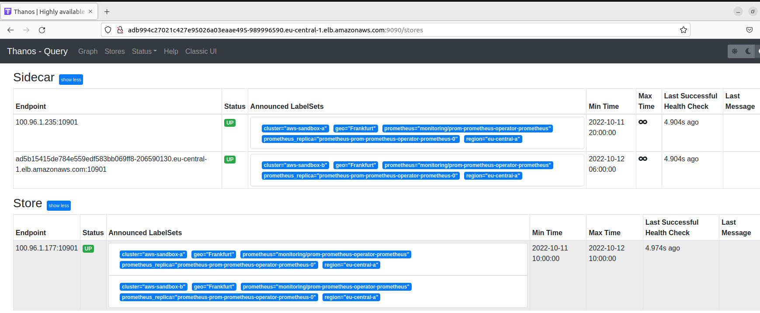

**Displaying metrics via Grafana.**

Prometheus operator installs grafana you only need to change the service from a cluster IP to LoadBalancer

kubectl edit svc prom-grafana -n monitoring

Once this is changed you can copy the loadbalancer address into a browser and login with default admin credentials.

In grafana - You will need to create a DataSource with URL to match the thanos-querier service name: <http://thanos-querier:9090>